Lab 2

ARTI 308 – Machine Learning
Academic Year (2025/2026) – 2nd Semester

Lab 2: Identifying ML Problems, Selecting Open Datasets, and Drawing a Methodology Diagram

Learning Goals:
By the end of this lab, you will be able to:
- Identify whether a problem is Regression, Classification, or Clustering
- Select a suitable dataset from open sources
- Define the target variable (if supervised)
- Write a clear problem statement
- Draw a methodology diagram

Part 1: Choosing an Open Dataset
Start by selecting one tabular dataset from an open-source platform. You may use any of the following resources:
- Kaggle: https://www.kaggle.com/datasets
- UCI Machine Learning Repository: https://archive.ics.uci.edu
- OpenML: https://www.openml.org
- Government open-data portals (for example: data.gov)
- Etc…
Your dataset should be in CSV or Excel format and should be suitable for a machine learning task such as prediction or pattern discovery.
Examples of suitable datasets:
- Predicting house prices based on size and location
- Classifying emails as spam or not spam
- Predicting whether a customer will churn
- Grouping customers based on behavior (clustering)
- Avoid image, audio, or text-heavy datasets for this lab.

Part 2: Defining the Machine Learning Problem
Once you select a dataset, your next task is to clearly define the machine learning problem.
Ask yourself:
- Is this a regression, classification, or clustering problem?
  - This is primarily a Regression problem (more specifically, a Time Series Regression problem).
- Is there a target variable? Yes.
- What is the model expected to learn or predict?
  - The model is expected to learn the spatio-temporal relationship and correlation between human mobility and viral transmission.
Write a short problem description in your own words.

Part 3: Loading and Inspecting the Dataset in Python
Create a Jupyter Notebook and load your dataset using Pandas.
At this stage, you only need to:
- Load the dataset
- Display its shape
- Preview the first few rows
- Check column names and data types
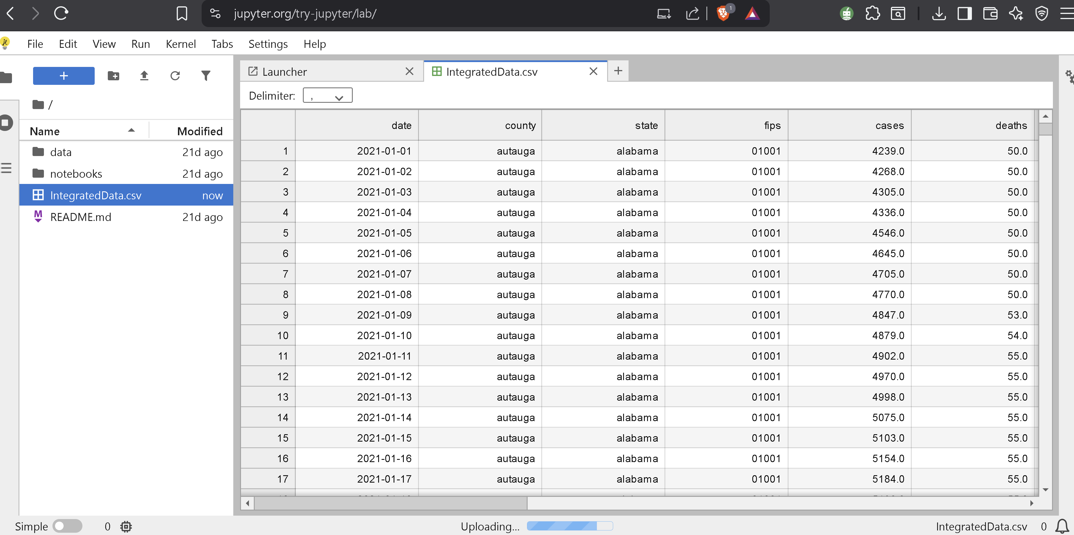

Part 4: Designing the Methodology Diagram
The final task in this lab is to create a methodology diagram that explains your machine learning workflow. This diagram should visually represent how the project would proceed from start to finish.
A typical methodology includes steps such as:
- Dataset selection
- Data loading
- Data preprocessing
- Train/test split
- Model training
- Model evaluation
- Results
You may create the diagram using any free tool, such as:
- draw.io: https://www.drawio.com
- Canva: https://www.canva.com
- Figma: https://www.figma.com
- Napkin: https://www.napkin.ai
- PowerPoint
- Etc…
- 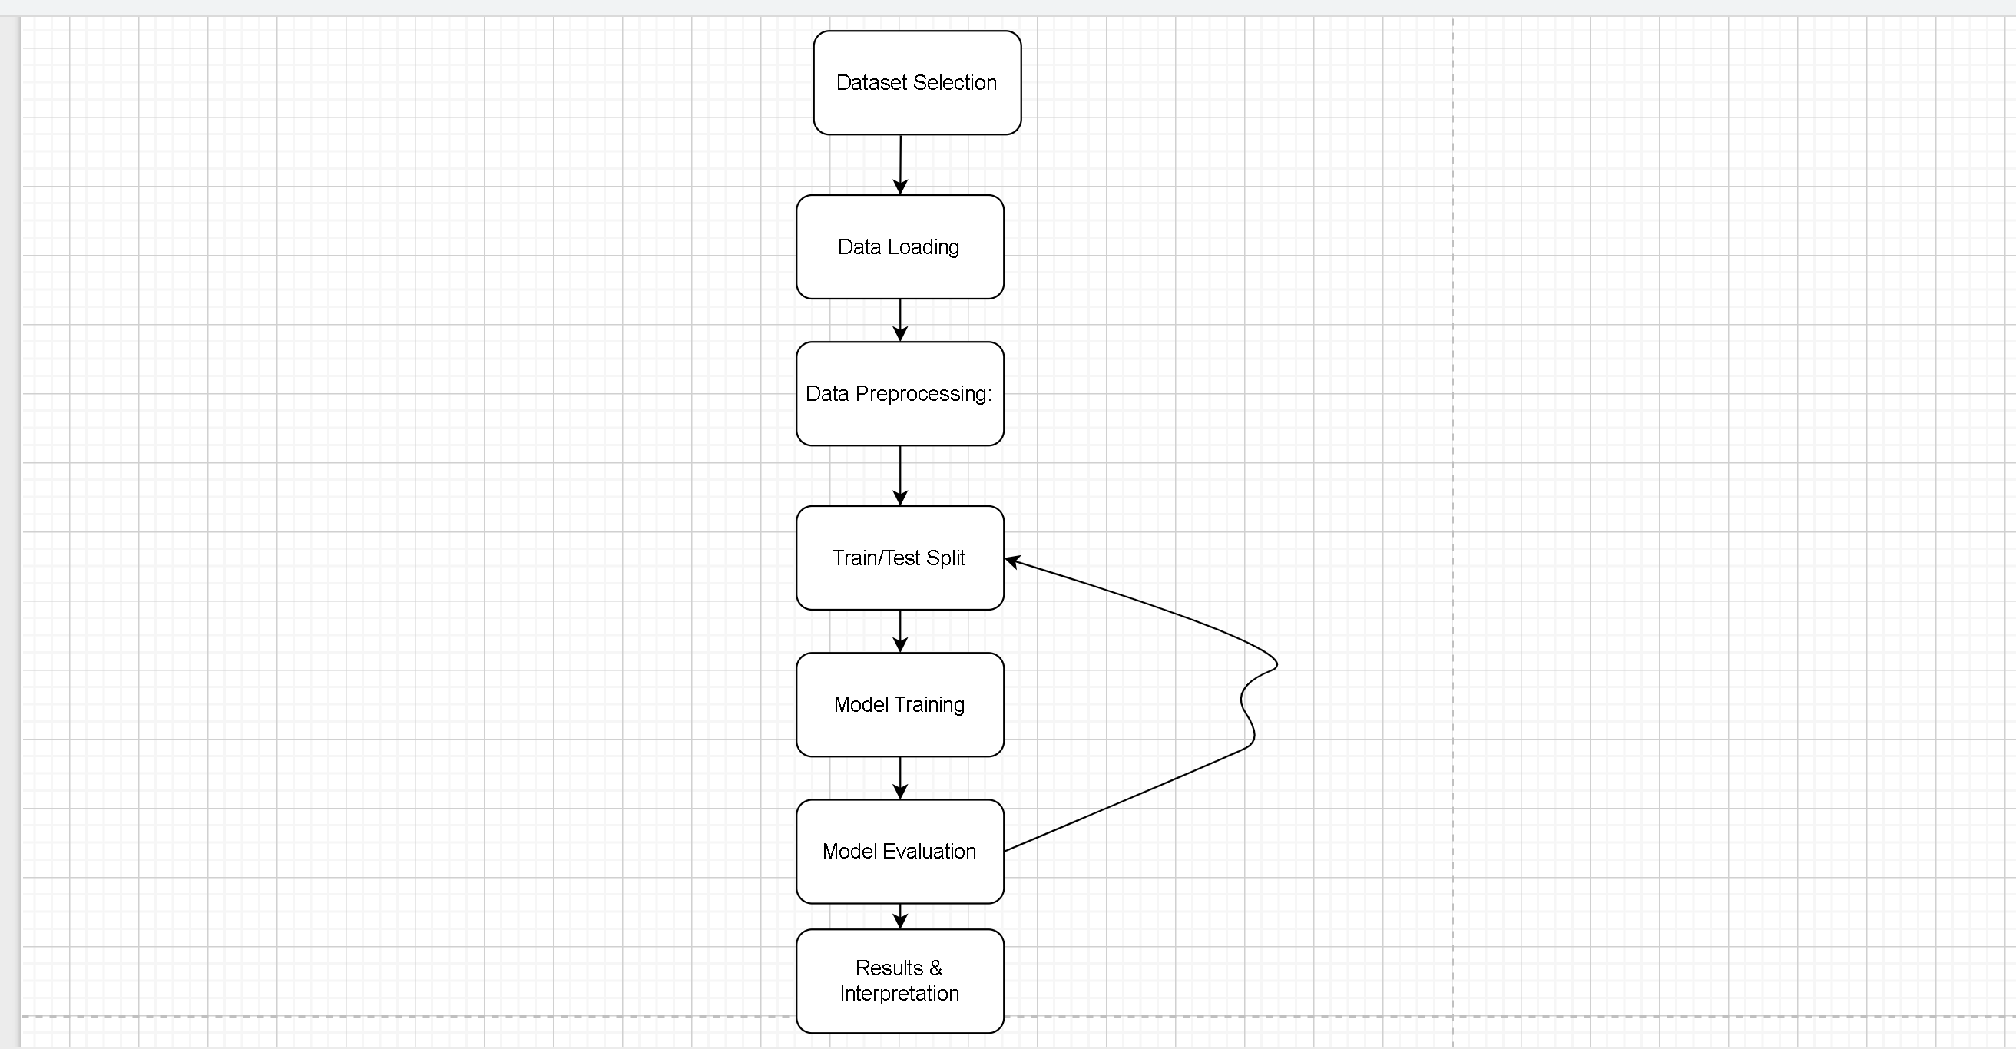
Export your diagram as a PNG or PDF and save it in your GitHub repository.
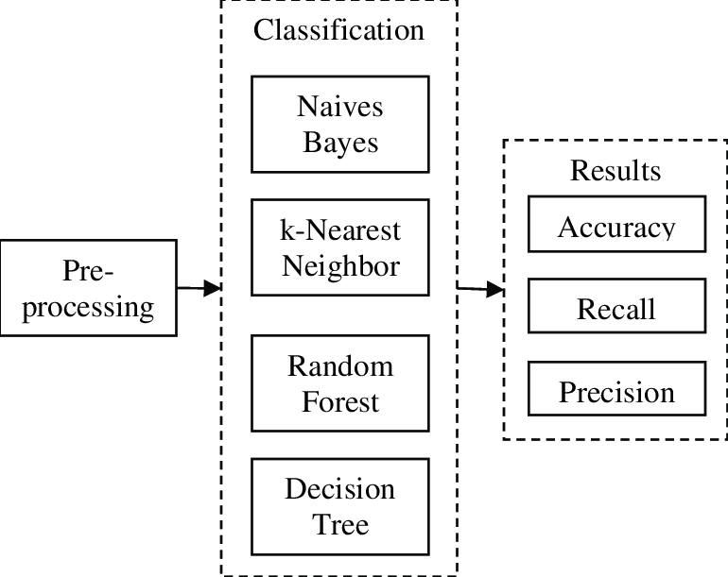
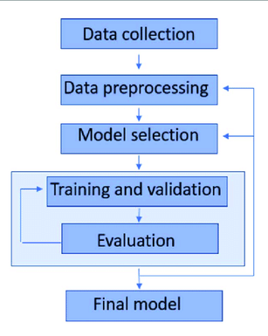
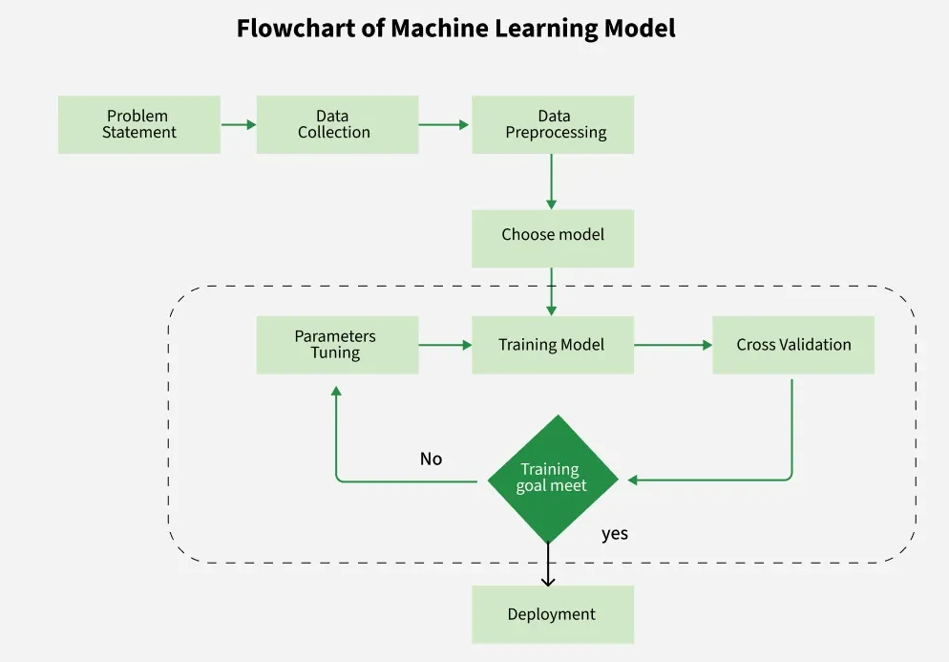
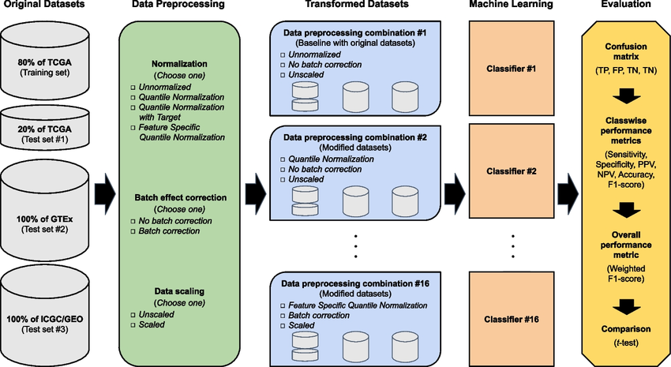
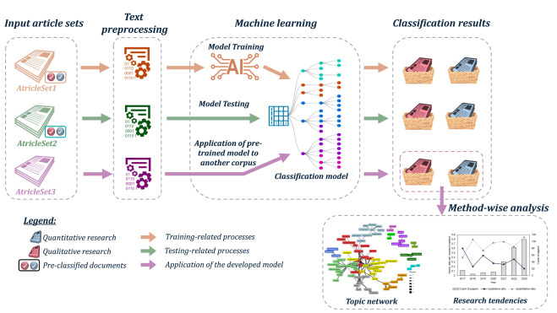

Assignment 2 - Instructions
Your work for this lab must be submitted through GitHub only.
Your GitHub repository must contain:
- A short written summary describing the dataset and the machine learning problem
- A Jupyter Notebook that loads the dataset and displays basic information
- The methodology diagram saved as an image or PDF
Submit only the GitHub repository link through the Assignment 2 submission link on Blackboard.
Do not upload files or screenshots directly to Blackboard. Make sure your repository is accessible.

